LEETCODE QUESTION
Calculate Delayed Arrival Time - LeetCode
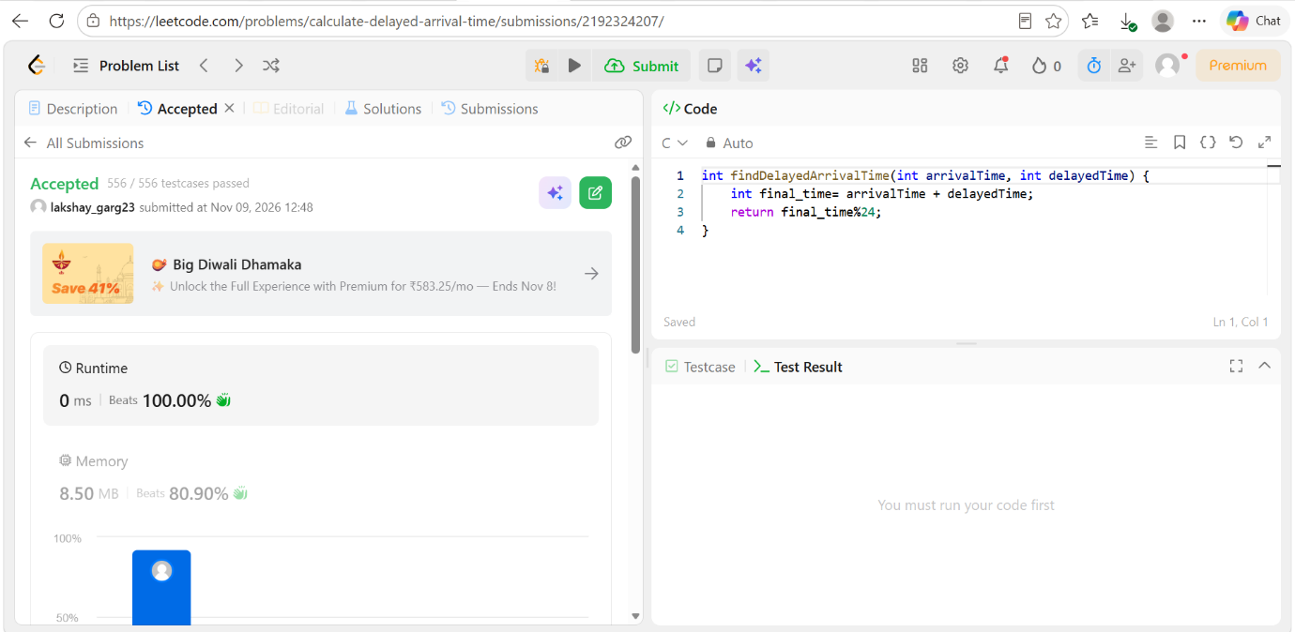

CODE
int findDelayedArrivalTime(int arrivalTime, int delayedTime) {
int final_time= arrivalTime + delayedTime;
return final_time%24;
}

